Sunny Solar Syndicate





Narmada Canal Solar Power Project

“ Canal-Top" solar energy plant

Narmada Canal, Gujarat, India

Narmada Canal - Wikipedia, the free encyclopedia
https://en.wikipedia.org/wiki/Narmada_Canal
Wikipedia
The Narmada Canal is a contour canal in northwestern India that brings water from the Sardar Sarovar Dam north through 460 kilometres (290 mi) of the state of Gujarat and then 74 kilometres (46 mi) into Rajasthan state.

Canal Solar Power Project - Wikipedia, the free encyclopedia

https://en.wikipedia.org/wiki/Canal_Solar_Power_Project
https://en.wikipedia.org/wiki/Canal_Solar_Power_Project
Wikipedia
The Canal Solar Power Project is a project launched in Gujarat, India, to use the 19,000-kilometre-long network of Narmada canals across the state for setting up ...

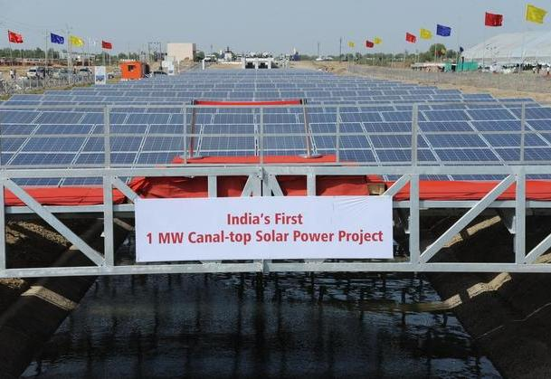

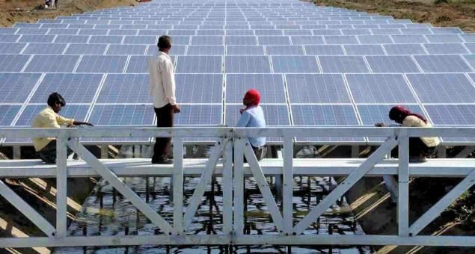

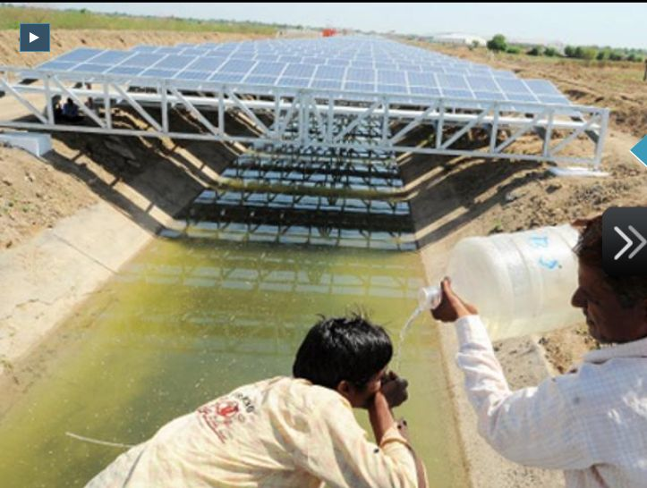

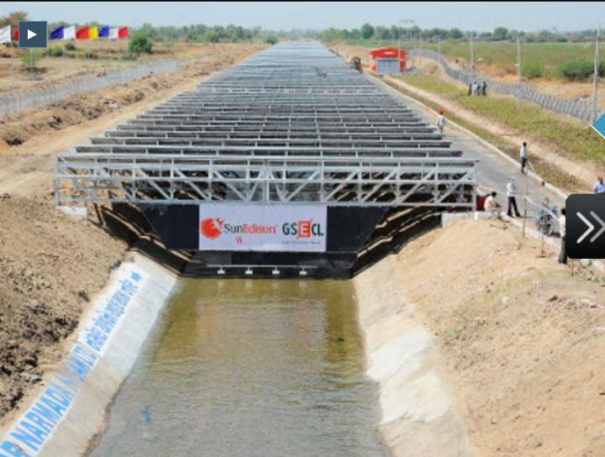

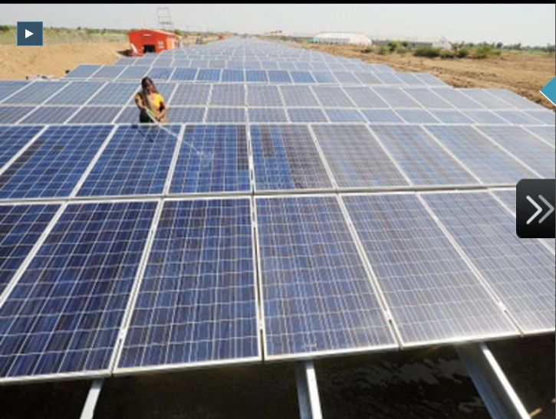

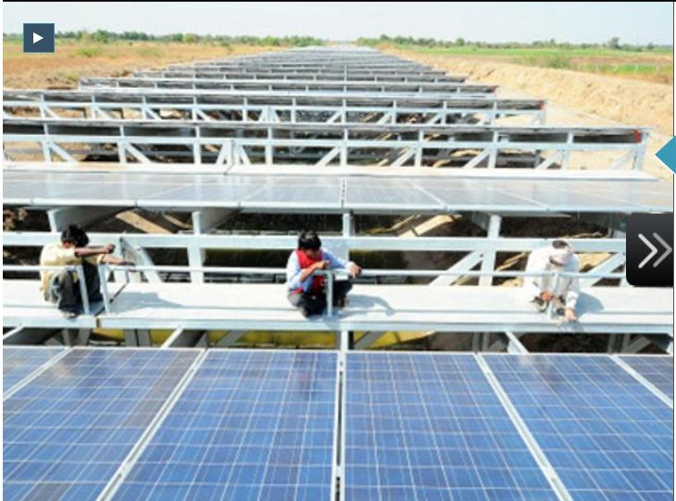

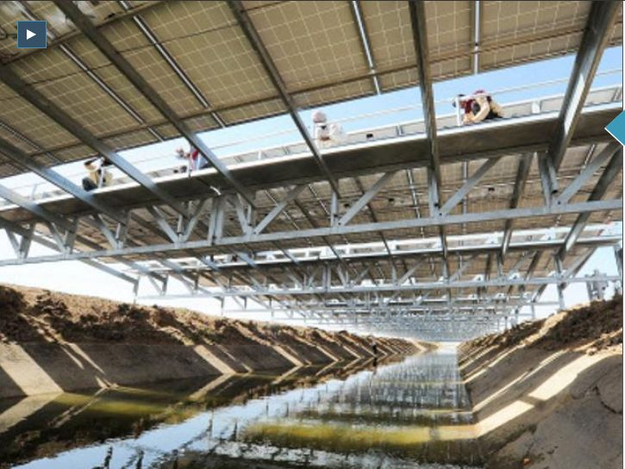

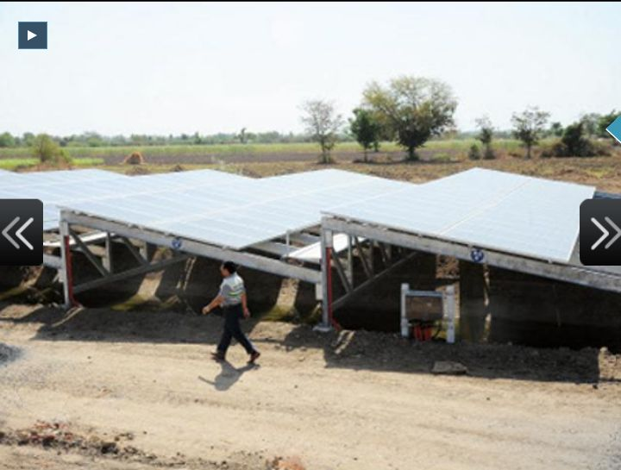

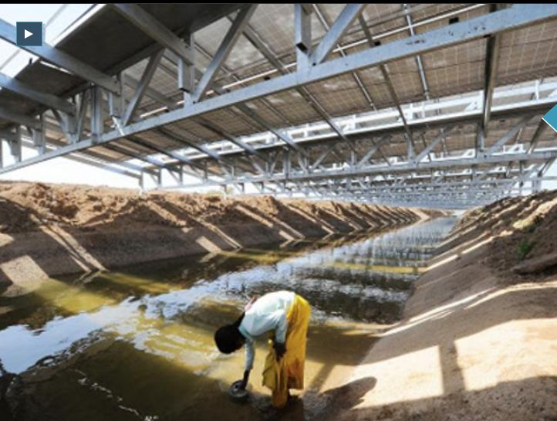

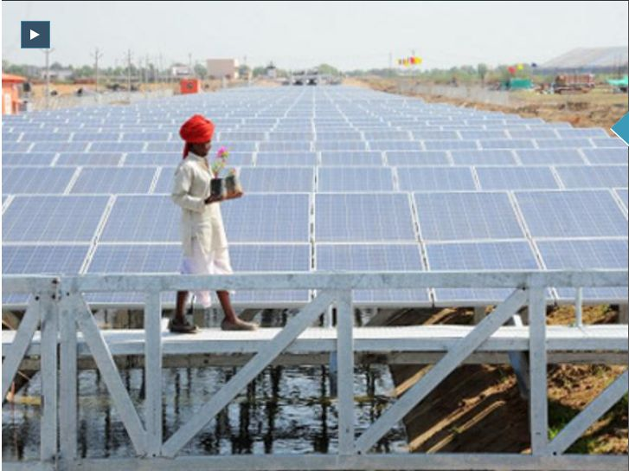

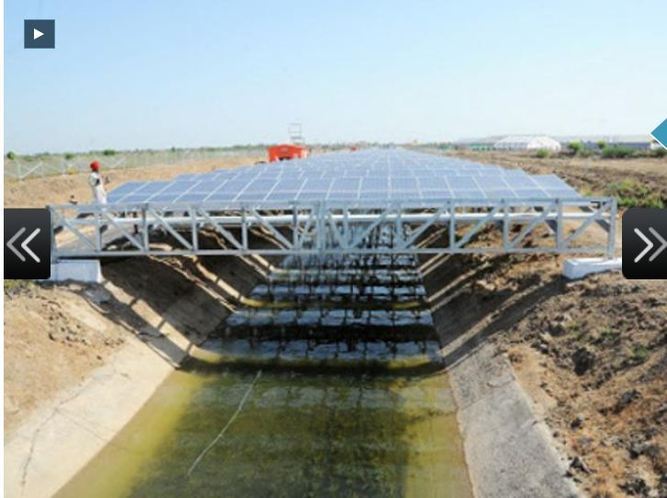

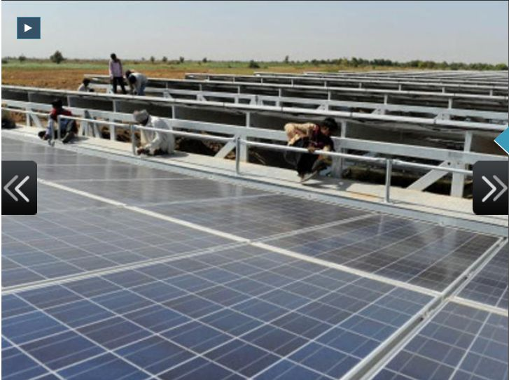

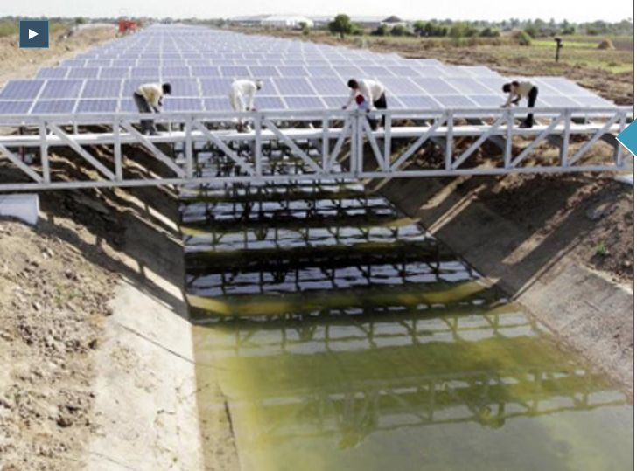

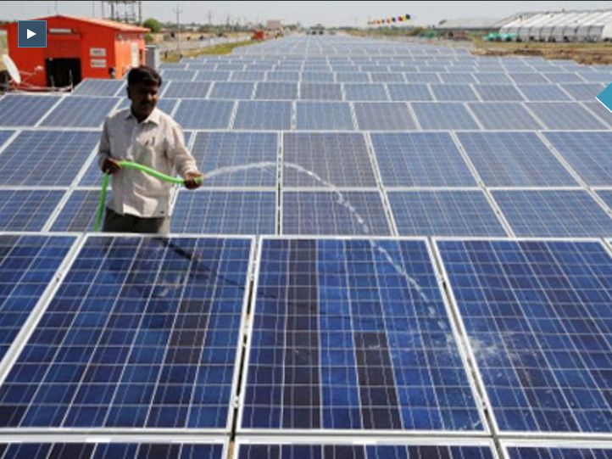

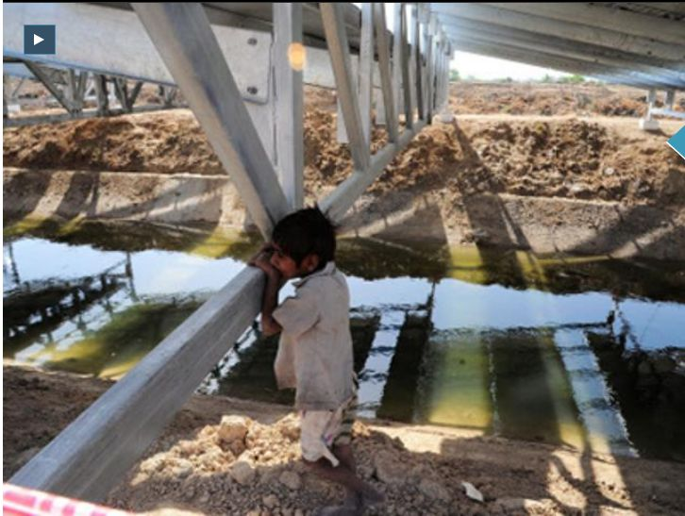

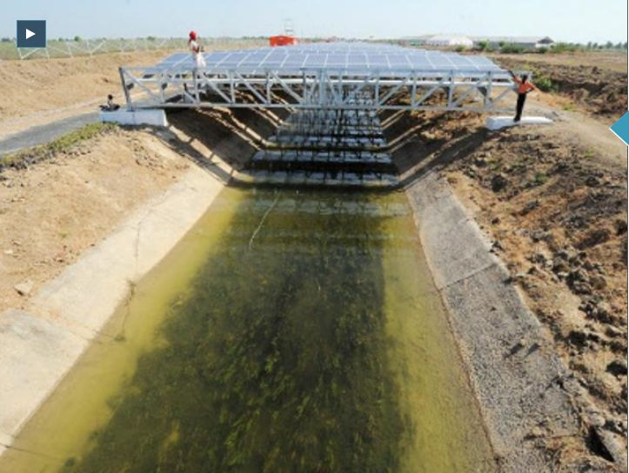

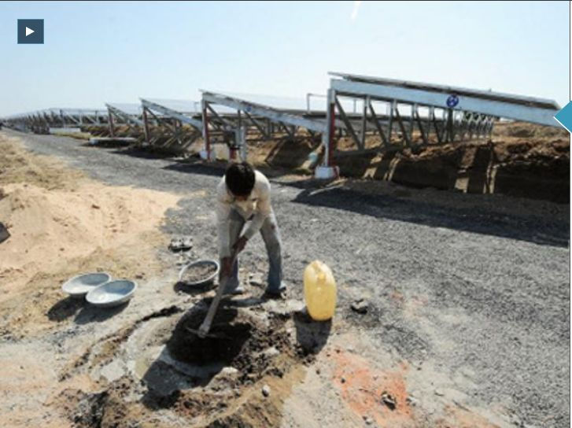

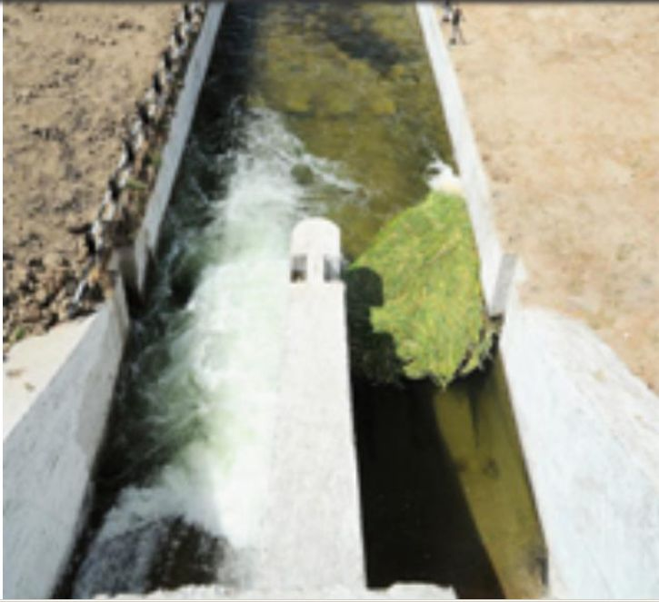

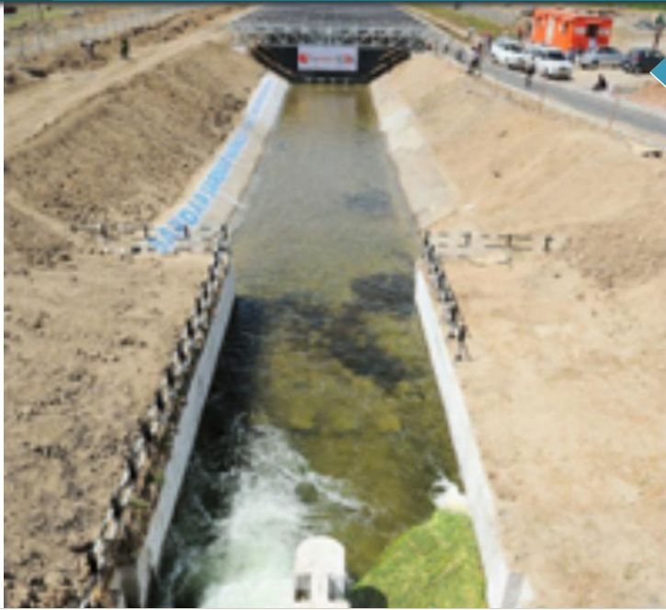

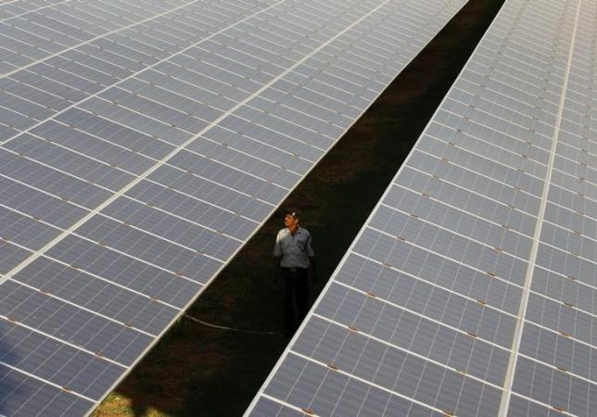

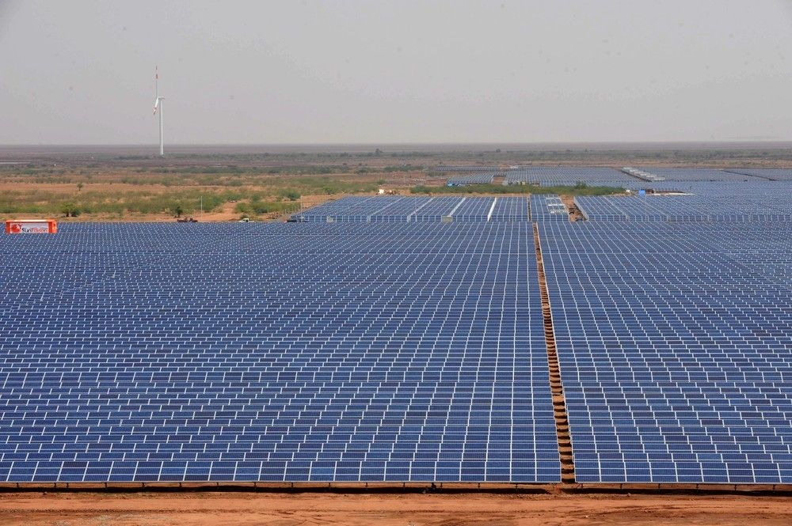

Sardar Sarovar Dam - Wikipedia, the free encyclopedia
https://en.wikipedia.org/wiki/Sardar_Sarovar_Dam
Wikipedia
The Sardar Sarovar Dam is a gravity dam on the Narmada river near Navagam, Gujarat in India ... Additionally, a power plant on the intake for the main canal contains five 50 MW Kaplan turbine-generators. .... and also that suitable vacant land for rehabilitating them is already in the possession of the respective States.

India builds solar plants atop canals to save land, water | Reuters
in.reuters.com/article/india-solar-idINKBN0KP0ZO20150116
Reuters
Jan 16, 2015 - India builds solar plants atop canals to save land, water ... "canal-top" solar energy plant in Vadodara district in India's western state of Gujarat. ... canal, though which irrigation water runs from a dam on the Narmada River.

Now, Gujarat to cover Narmada canals with solar panels! | Business Line
www.thehindubusinessline.com/...gujarat...narmada-canals...
Business Line
Apr 23, 2012 - Canal solar power: Gujarat has attracted investments of Rs 9,000 crore so ... 19,000 km-long network of Narmada canals across the State for setting up .... India braces for more heat after temperatures break records 2 min. ago.

Sardar Sarovar Dam (SSD), Gujarat - Water Technology
www.water-technology.net/projects/sardar-sarovar-dam-gujarat/
... power and supply water for drinking and irrigation to states of Gujarat, Madhya Pradesh ... Narmada is the fifth largest river in India, traversing 1,312km from the ... Significance of the SSP for Gujarat and Narmada Main Canal (NMC) details.

Gujarat's Pride-10 Outstanding Infrastructure of The State
www.walkthroughindia.com/.../gujarat-pride-10-outstanding-infrastructu...
17 Most Popular Indian States for Domestic and International Tourist .... Kilometre long network of Narmada canals is first ever such project in India and Gujarat ...

Gujarat lights up canal with 10 MW project: pv-magazine
www.pv-magazine.com/.../gujarat-lights-up-canal-with-10-mw-project_1...
Aug 14, 2013 - The Indian state of Gujarat is set to expand canal-top solar power ... SSNNL's 1 MW canal-top project in Narmada became operational last year.

Solar panels atop Narmada river - How Gujarat canal is turning into a ...
economictimes.indiatimes.com › ... › Infrastructure
The Economic Times
Apr 23, 2012 - India's first 1MW canal-top solar power plant will generate 1.6 million units of ... The project has been developed by the Gujarat State Electricity ...

Gujarat plans 10km solar topped canal scheme | Climate Home ...
www.climatechangenews.com/.../gujarat-plans-10km-solar-topped-canal-...
Aug 15, 2013 - The India state of Gujarat aims to save water and boost electricity ... already constructed a similar 1MW project on the Narmada canal in 2012.

