Lake Elsinore 2.79 Acres - Club House Proposal

1. Proposal: Lake Elsinore Rome Hill 2.79 Acres - Club House

2. Sale Price: $280,000.00

3. Land Owner: Tseng Family Living Trust

4. Location: 0 Como Street, Lake Elsinore, CA 92530
Land Size: 2.79 Acres
APN # 371-100-005

5. Building structure use for: Club House

6. Land Use: Lot size: 2.79 Acres
Width Street side 97 Feet
Depth Hill side 1260 Feet

2.79 Acres could build 1 club house,

7. Contact: Dr. Ruy Lee
1008 E. Las Tunas Drive # D, San Gabriel, CA 91776
626-287-5988 ruylee@pacbell.net

Legal Statement Illumination Imagines Pictures are for Reference only. Buyer shall consult with Lake Elsinore City Planning Department for Building
Site/Plot Plan approval. Buyer shall satisfy with Self Feasibly Study. Sale price for land value only not included house structure and permit.

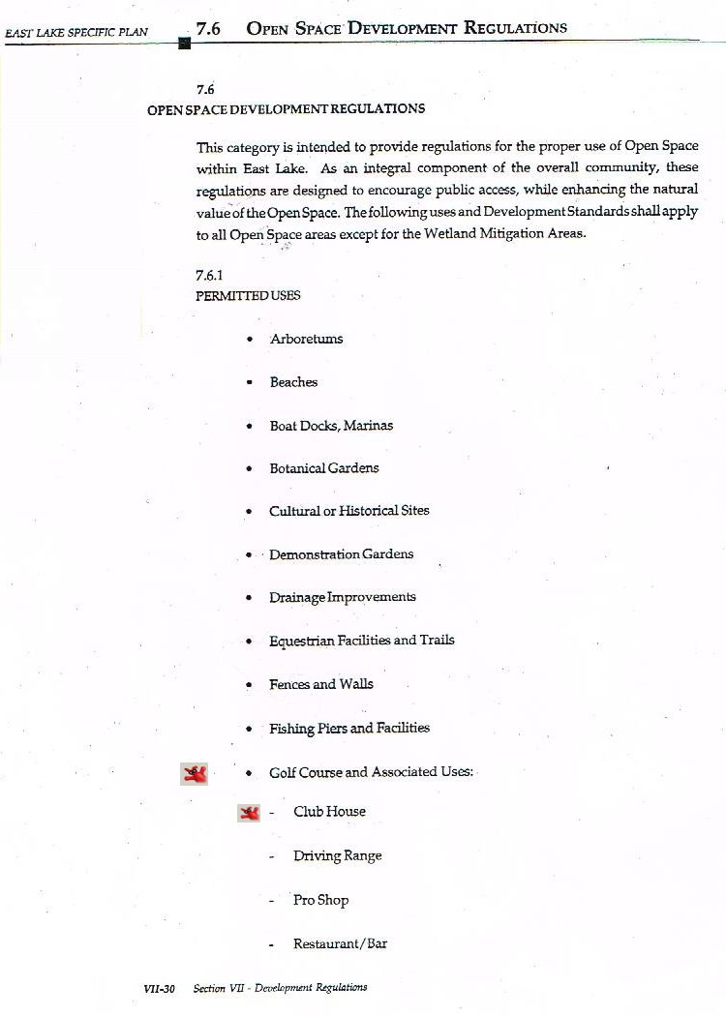

Legal Statement
Illumination Imagines Pictures are for Reference only. Buyer shall consult with Lake Elsinore City Planning Department for Building
Site/Plot Plan approval. Buyer shall satisfy with Self Feasibly Study. Sale price for land value only not included house structure and permit.
Rome Hill Tseng House Design 371-100-005 2.79 Acres 97’ x 1260’

House

85’ x 35’ = 2,975 SF or More SF by Buyer

915'

5’ House Front Side 82’ 10’
Fire Double
Lane Drive 345’
Lane

20’ Set back

5’ Easement

Retaining Wall
Rain Water Flow Rain Water Flow
Drainage Drainage

315’ Hill Side

Sun Solar Panel

1260’

5’ Easement

97’

Legal Statement
Illumination Imagines Pictures are for Reference only. Buyer shall consult with Lake Elsinore City Planning Department for Building
Site/Plot Plan approval. Buyer shall satisfy with Self Feasibly Study. Sale price for land value only not included house structure and permit.
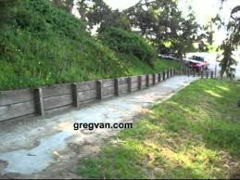
Retaining Wall
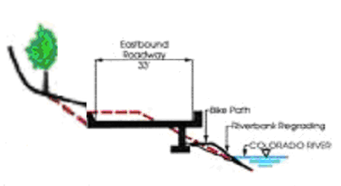
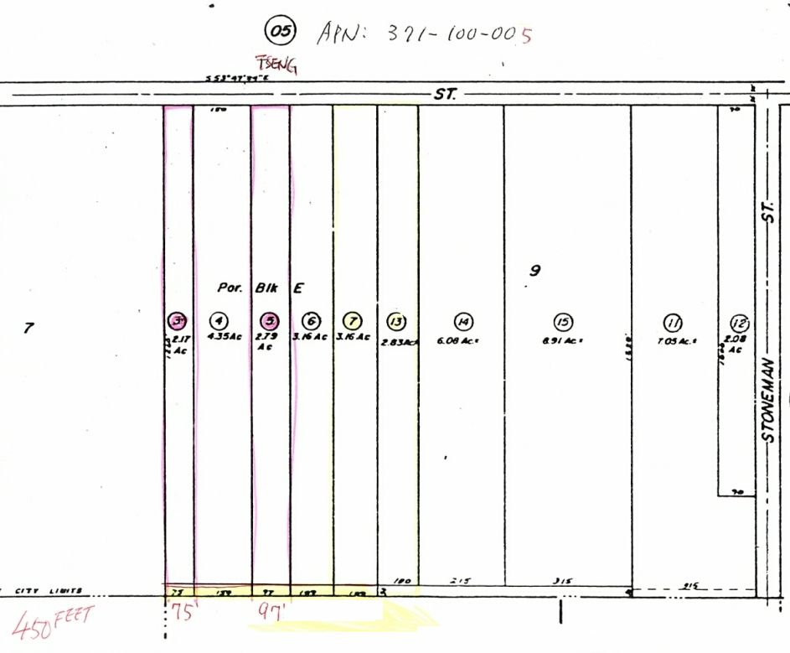
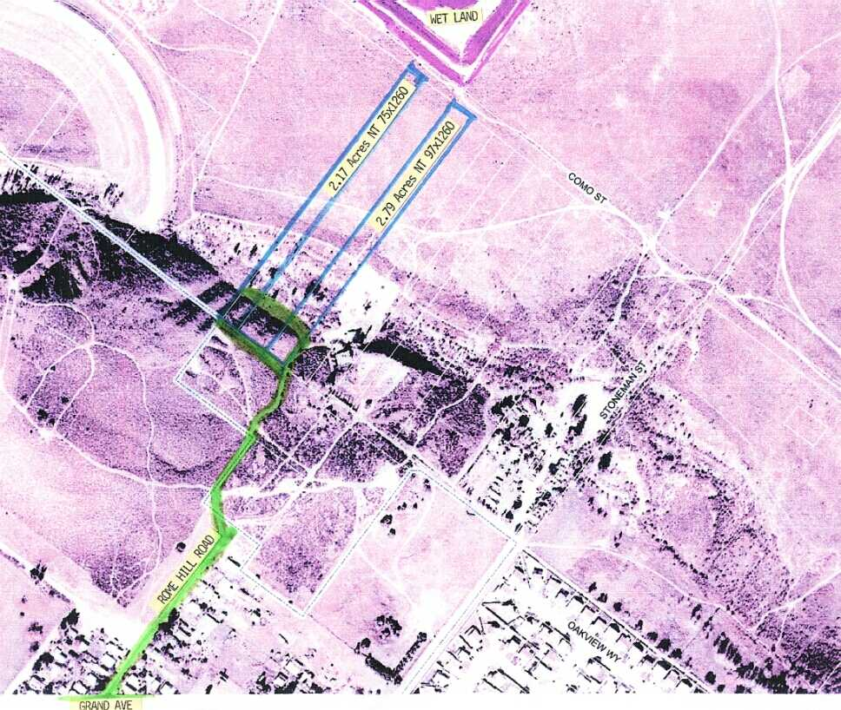
Land Information http://www.apace.us/realty/land/land.htm
Legal Statement
Illumination Imagines Pictures are for Reference only. Buyer shall consult with Lake Elsinore City Planning Department for Building
Site/Plot Plan approval. Buyer shall satisfy with Self Feasibly Study. Sale price for land value only not included house structure and permit.
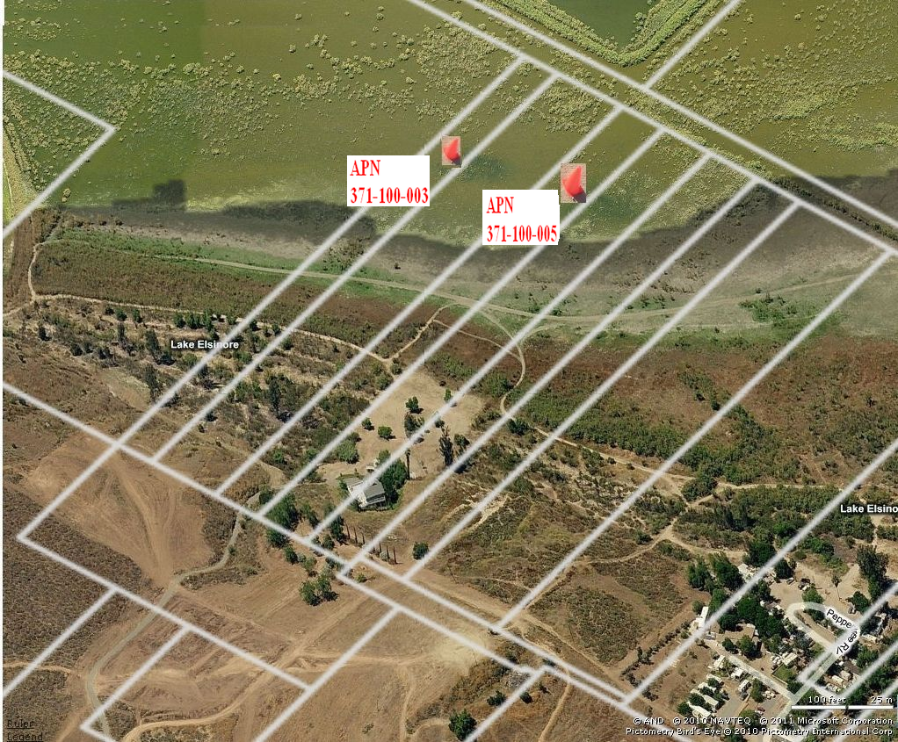

Legal Statement
Illumination Imagines Pictures are for Reference only. Buyer shall consult with Lake Elsinore City Planning Department for Building
Site/Plot Plan approval. Buyer shall satisfy with Self Feasibly Study. Sale price for land value only not included house structure and permit.

Hill Side

Sun Solar Panel

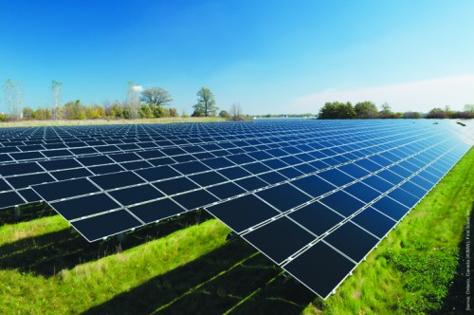

Legal Statement
Illumination Imagines Pictures are for Reference only. Buyer shall consult with Lake Elsinore City Planning Department for Building Site/Plot Plan approval. Buyer shall satisfy with Self Feasibly Study. Sale price for land value only not included house structure and permit.

Rome Hill House Design Imagine View Elevation

Project Proposal
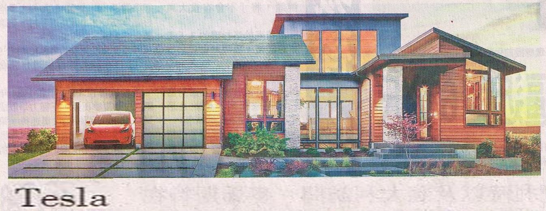
Front Elevation Right Side Car Entrance

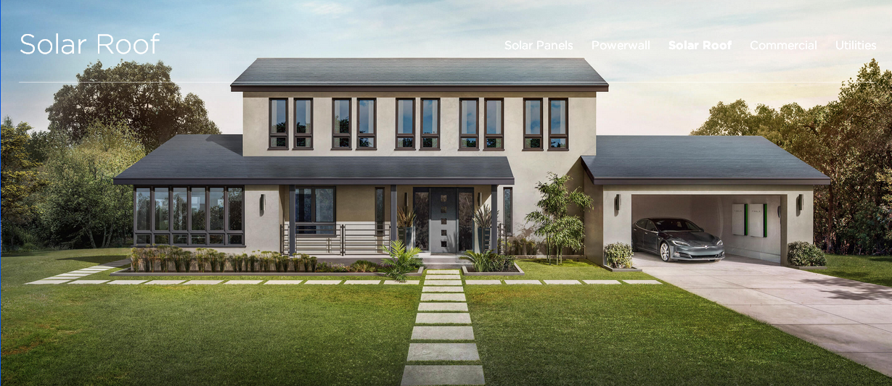
Front Elevation Left Side Car Entrance

Designer: www.tesla.com
https://www.tesla.com/solarroof
https://www.tesla.com/contact
Sales Toll free: (888) 51-TESLA or (888) 518-3752
Local: (650) 681-5100
Fax: (650) 681-5101
NASales@tesla.com
EnergyOrdersNA@tesla.com

Legal Statement
Illumination Imagines Pictures are for Reference only. Buyer shall consult with Lake Elsinore City Planning Department for Building
Site/Plot Plan approval. Buyer shall satisfy with Self Feasibly Study. Sale price for land value only not included house structure and permit.
Tesla Trade Mark belongs to Tesla Company. Please contact Tesla Company Direct.
Rome Hill House Design Imagine View Project Proposal

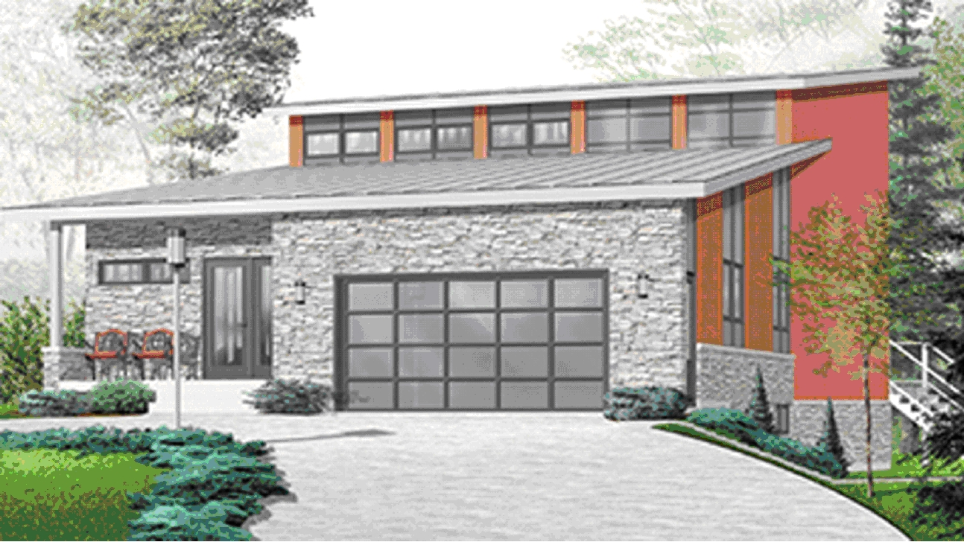
Front Elevation Right Side Car Entrance
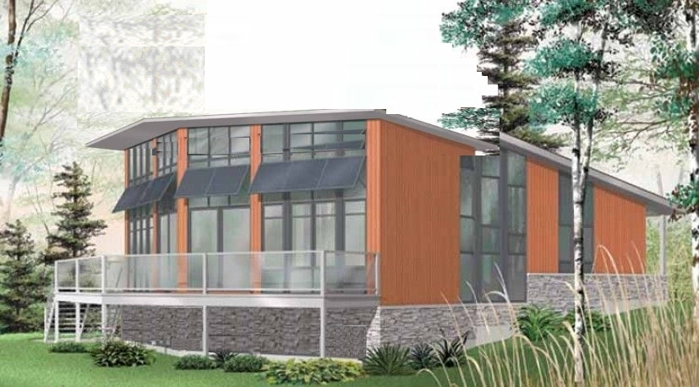
Back Elevation Porch

Designer: www.homeplans.com
http://www.homeplans.com/house-plans/hp/homepw74082.html
Order #: HOMEPW74082
Phone: 1-888-447-1946
Representative: Ms. Carol

http://www.apace.us/realty/land/land.htm

Legal Statement
Illumination Imagines Pictures are for Reference only. Buyer shall consult with Lake Elsinore City Planning Department for Building
Site/Plot Plan approval. Buyer shall satisfy with Self Feasibly Study. Sale price for land value only not included house structure and permit.

Rome Hill House Design Imagine View Project Proposal

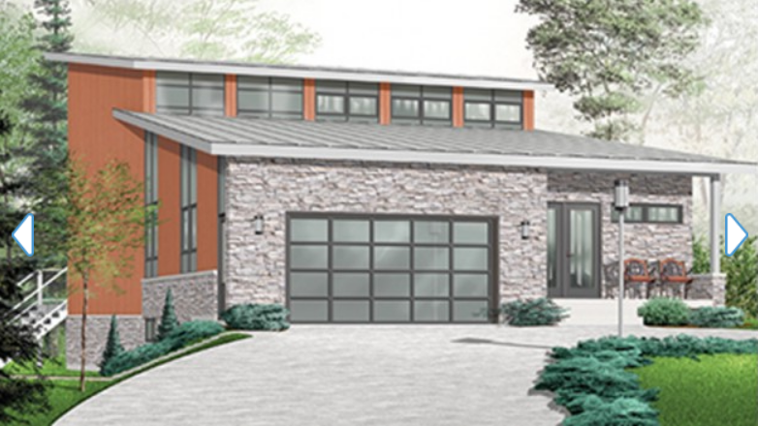
Front Elevation Left Side Car Entrance

Back Elevation Porch

Designer: www.homeplans.com
http://www.homeplans.com/house-plans/hp/homepw74082.html
Order #: HOMEPW74082
Phone: 1-888-447-1946
Representative: Ms. Carol

Legal Statement
Illumination Imagines Pictures are for Reference only. Buyer shall consult with Lake Elsinore City Planning Department for Building
Site/Plot Plan approval. Buyer shall satisfy with Self Feasibly Study. Sale price for land value only not included house structure and permit.

