Wildomar 5.38 Acres - Tseng Medical Center & Senior Boarding House Proposal

1. Proposal: Wildomar 5.38 Acres - Tseng Medical Center & Senior Boarding House

2. Land Owner: Tseng Family Living Trust

3. Location: 21026 Palomar Street, Wildomar, CA 92595
Land Size: 5.38Acres
APN # 368-200-034

4. Building structure use for: Tseng Medical Center & Senior Boarding House

5. Tseng Medical Center supporters: Dr. John Tseng MD
Dr. William Tseng MD MPH
Dr. Linda Tseng MD

6. Senior Boarding House: Medical Support by Tseng Medical Center
Medical Care and Rehabilitation for Senior

7. Land Use: Lot size: 5.38 Acres
Width Street side 500 Feet
Depth Hill side 470 Feet

5.38 Acres will divide to 4 equal size Lots,
Each Lot is 1.345 Acre
Each Lot size: Width Street side 125 Feet
Depth Hill side 470 Feet

5.38 Acres apply to
Four Senior Boarding House and
Four Medical Commercial Building

8. Contact: Dr. Ruy Lee
1008 E. Las Tunas Drive # D, San Gabriel, CA 91776
626-287-5988 ruylee@pacbell.net

Addition Information:

7. Land Use: Lot size: 5.38 Acres
Width Street side 500 Feet
Depth Hill side 470 Feet

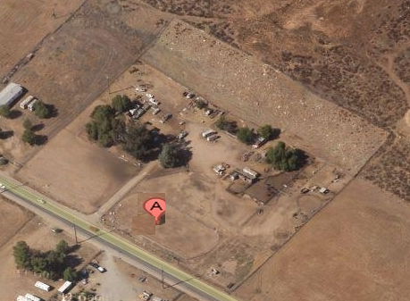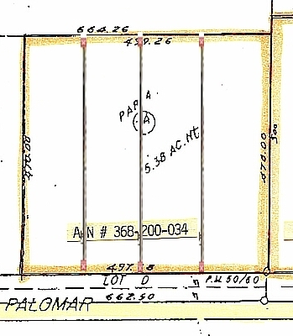
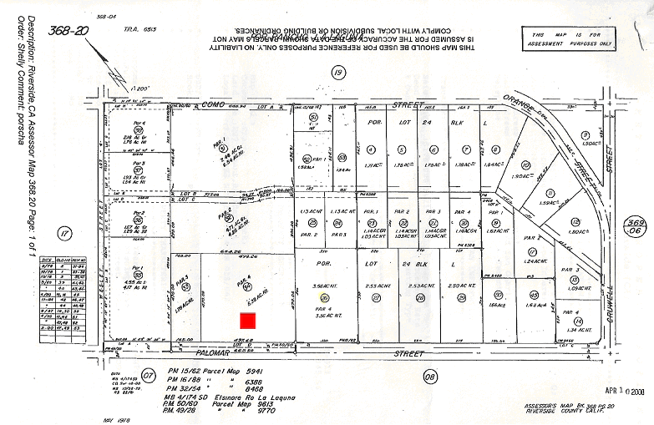
Legal Statement
Illumination Imagines Pictures are for Reference only. Buyer shall consult with Lake Elsinore City Planning Department
for Building Site/Plot Plan approval. Buyer shall satisfy with Self Feasibly Study. Sale price for land value only not included house structure and permit.

Addition Information:

7. Land Use: Lot size: 5.38 Acres
Width Street side 500 Feet
Depth Hill side 470 Feet

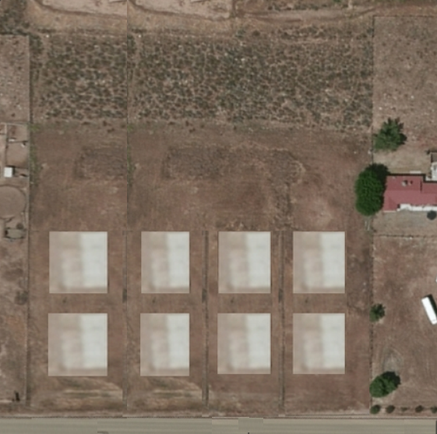

Legal Statement
Illumination Imagines Pictures are for Reference only. Buyer shall consult with Lake Elsinore City Planning Department
for Building Site/Plot Plan approval. Buyer shall satisfy with Self Feasibly Study. Sale price for land value only not included house structure and permit.

Plot / Site Plan

Hill Side

Sun Solar Panel Area

Rain Rain
Water Water

Rain Water Flow

Retaining Wall

Drainage Drainage

Parking Space Lot

Parking Space Lot

Parking Space Lot

Parking Space Lot

Parking Space Lot

Tseng Medical Building

Tseng Medical Building

Tseng Clinic Entrance Design

Set Back
Land for City Enlarge Side Walk

Palomar Street

Legal Statement
Illumination Imagines Pictures are for Reference only. Buyer shall consult with Lake Elsinore City Planning Department
for Building Site/Plot Plan approval. Buyer shall satisfy with Self Feasibly Study. Sale price for land value only not included house structure and permit.

Palomar Street side

Tseng Clinic Sign Structure

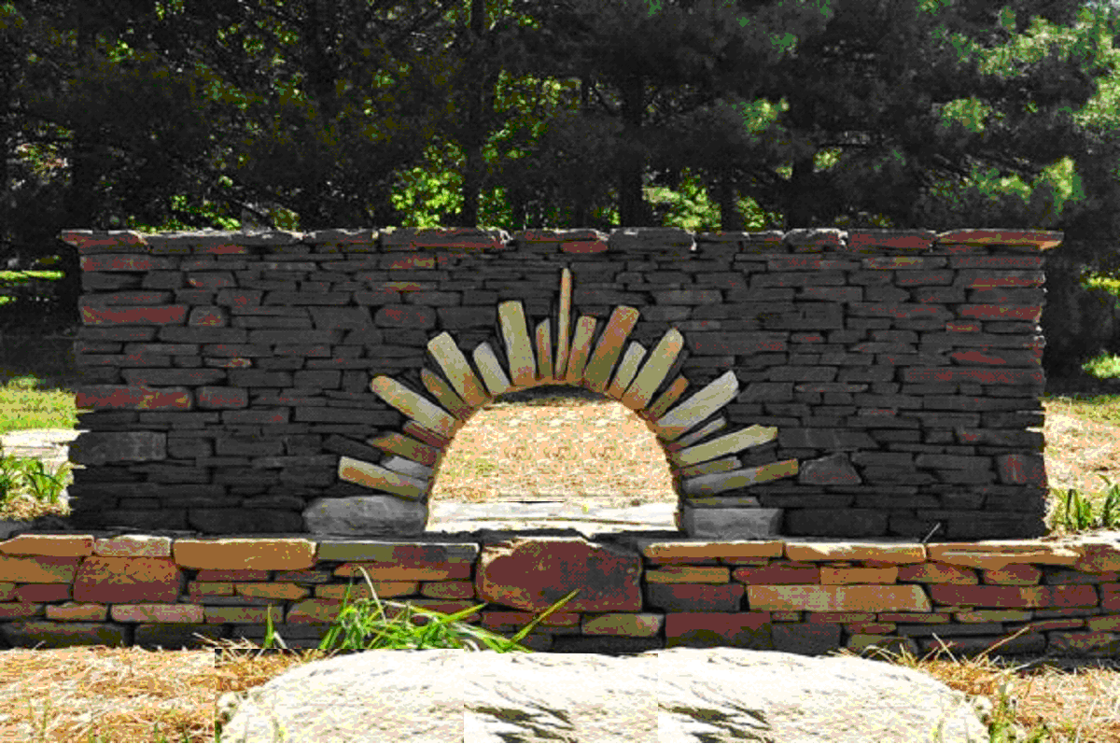

Legal Statement
Illumination Imagines Pictures are for Reference only. Buyer shall consult with Lake Elsinore City Planning Department
for Building Site/Plot Plan approval. Buyer shall satisfy with Self Feasibly Study. Sale price for land value only not included house structure and permit.

Street side Entrance

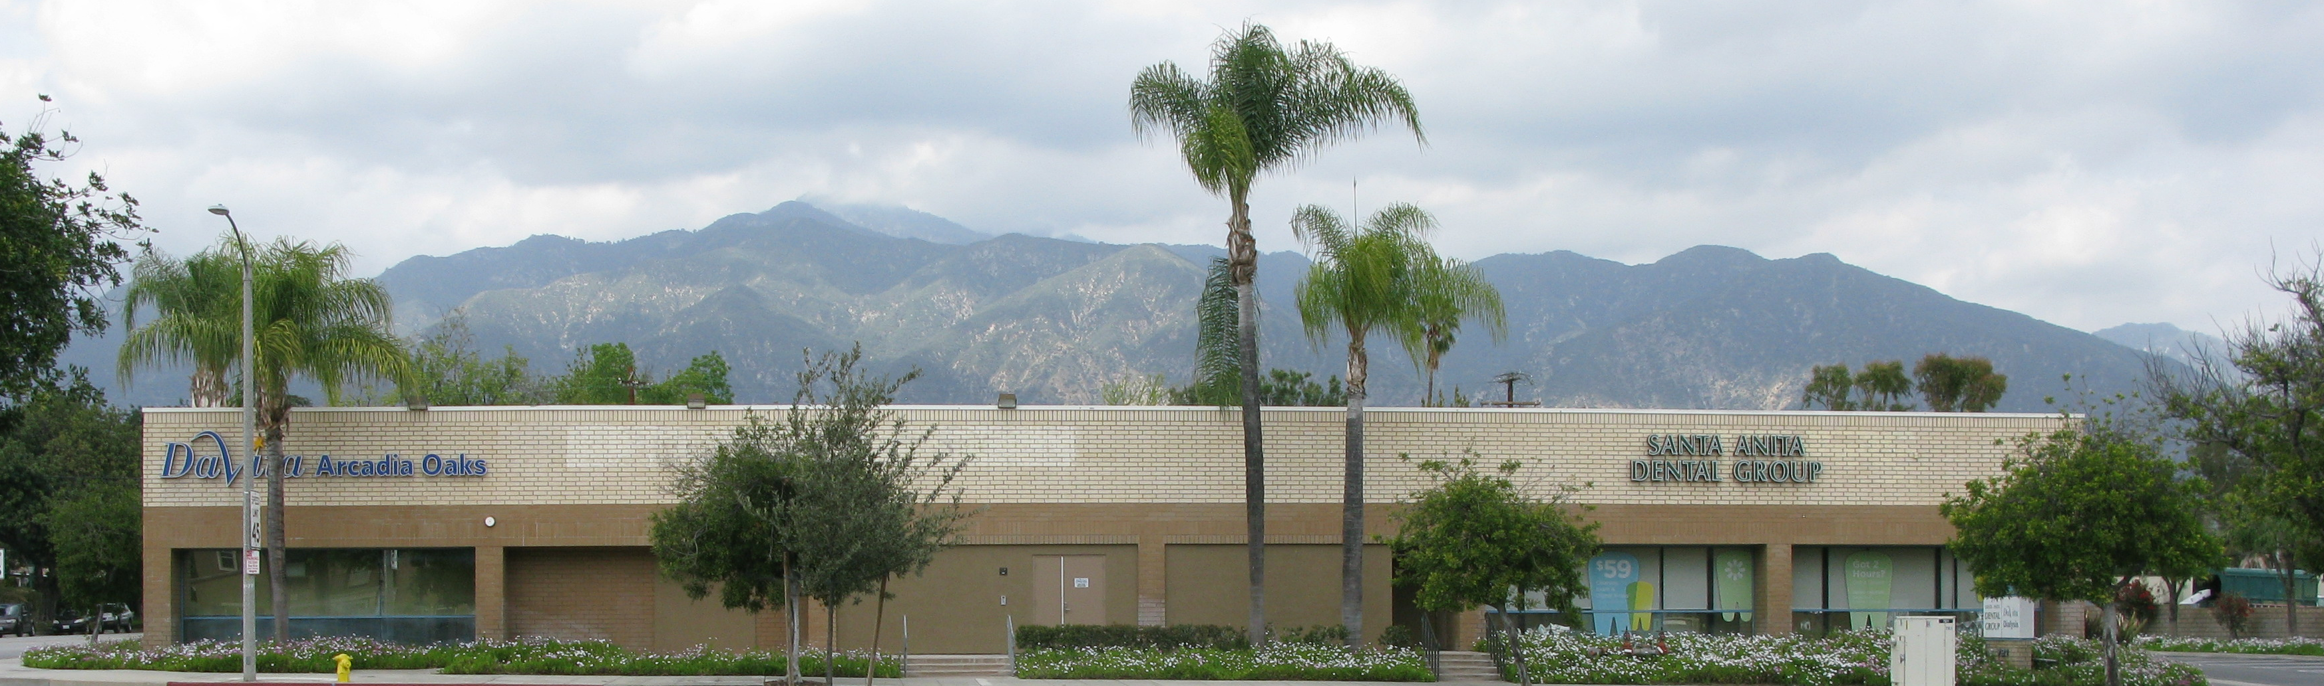

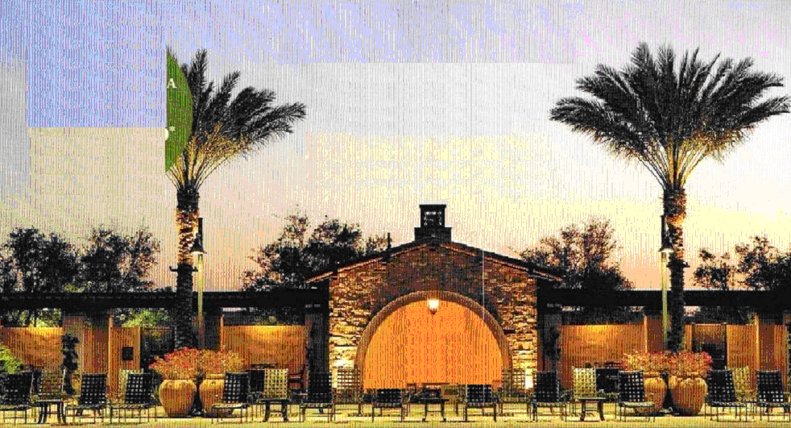

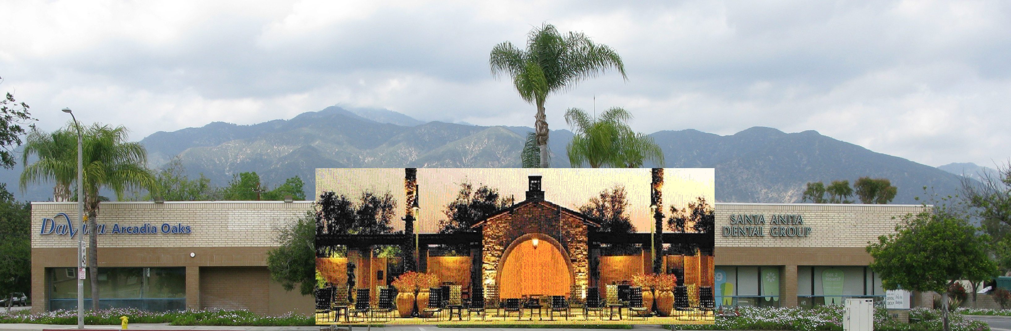

Legal Statement
Illumination Imagines Pictures are for Reference only. Buyer shall consult with Lake Elsinore City Planning Department
for Building Site/Plot Plan approval. Buyer shall satisfy with Self Feasibly Study. Sale price for land value only not included house structure and permit.

Parking Space Lot

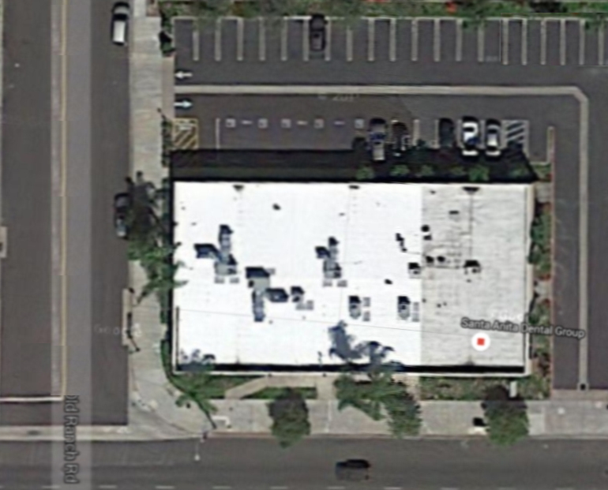

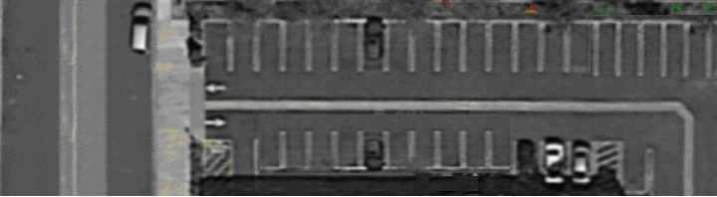

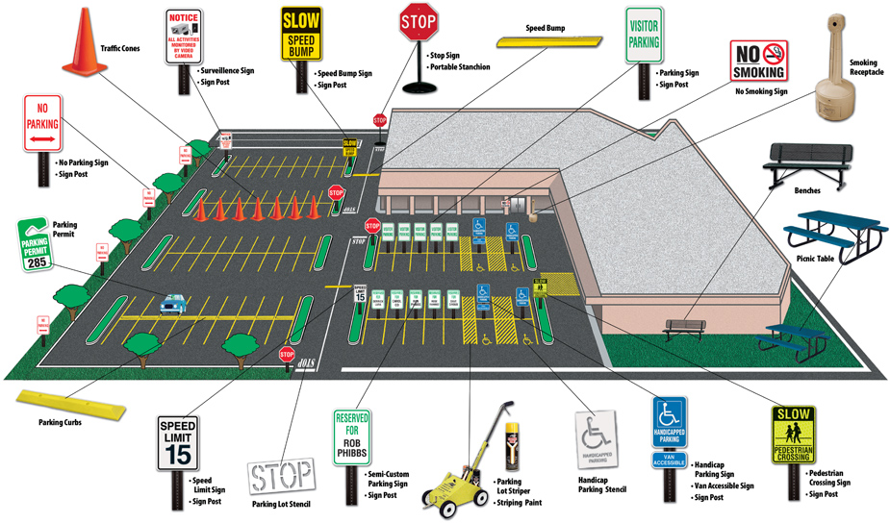

Legal Statement
Illumination Imagines Pictures are for Reference only. Buyer shall consult with Lake Elsinore City Planning Department
for Building Site/Plot Plan approval. Buyer shall satisfy with Self Feasibly Study. Sale price for land value only not included house structure and permit.

Hill Side

Retaining Wall

Collect and direct rain water to property both sides.
It’s preventing water flow over and erotic to Parking Space Lot and Building.

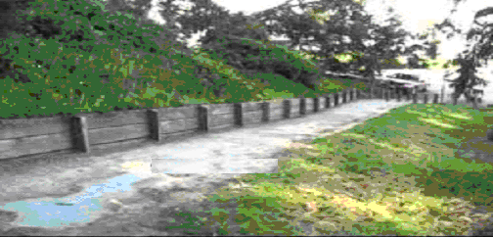

Hill Side

Sun Solar Panel Area

Rain Rain
Water Water

Rain Water Flow

Retaining Wall

Drainage Drainage

Legal Statement
Illumination Imagines Pictures are for Reference only. Buyer shall consult with Lake Elsinore City Planning Department
for Building Site/Plot Plan approval. Buyer shall satisfy with Self Feasibly Study. Sale price for land value only not included house structure and permit.

Hill Side

Sun Solar Panel



Legal Statement
Illumination Imagines Pictures are for Reference only. Buyer shall consult with Lake Elsinore City Planning Department
for Building Site/Plot Plan approval. Buyer shall satisfy with Self Feasibly Study. Sale price for land value only not included house structure and permit.

